**BSC2010 MODULE 2 UNIT 1 WORKSHEET ___________________________________**

WILLOUGHBY NAME

**Chapter 6 – METABOLISM**

1. Define metabolism.

1. Explain the difference between anabolism and catabolism.

1. Write the chemical equation for the catabolism of glucose.

1. Explain what is meant by the term “metabolic pathway”.

1. Draw simple sketches to show the difference between anabolism and catabolism. Be sure to include a representation of how energy is either taken up by the reaction or released by the reaction.

1. Add labels to the above diagram, indicating which reaction is exergonic and which reaction is endergonic.
2. These diagrams show two different types of energy on a molecular/cellular level. On the lines provided, write “potential” or “kinetic” to indicate the type of energy shown.

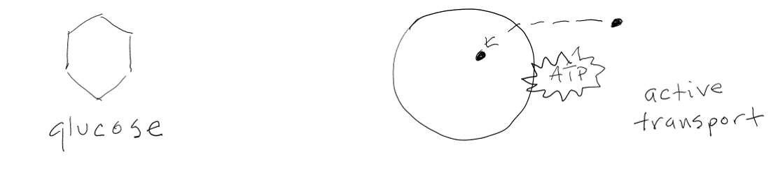

______________________________ ______________________________

1. What part of a molecule holds a type of potential energy known as chemical energy?

1. Define “free energy”.

1. Define “activation energy”.
2. What is entropy?

1. The original energy source for most living systems is ____________________.
2. State the First Law of Thermodynamics and the Second Law of Thermodynamics.

1. How is the concept of “heat” related to molecule movement?

1. If energy enters the biosphere in the form of sunlight, in what form does energy *leave* a biological system?

1. One of these two diagrams represents entropy. Which one? (circle your choice)

1. Complete this table.

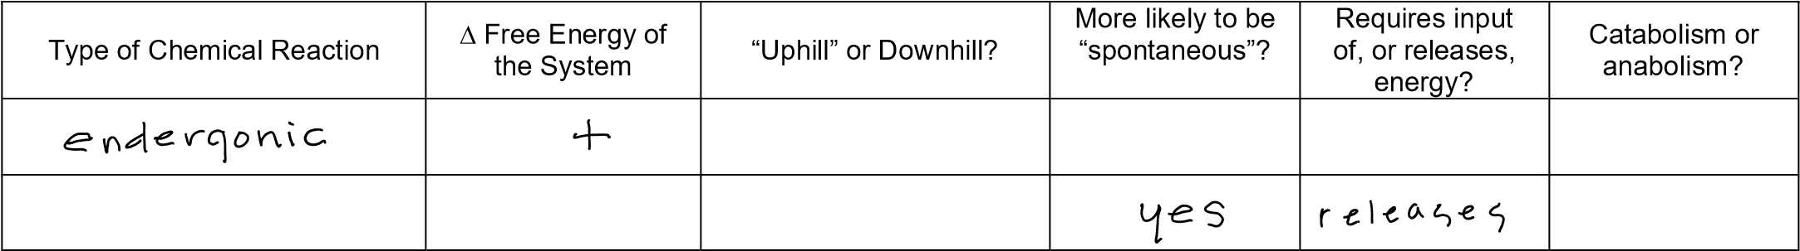

*Note: “∆” is pronounced “delta” and it means “change” or difference”.*

1. The graph below indicates the progress over time of a chemical reaction.

Draw a bracket to label the area of the curve representing the “activation energy”. Is the reaction endergonic or exergonic? ____________________

Draw arrows from the words “reactant” and “product” to label the corresponding parts of the diagram.

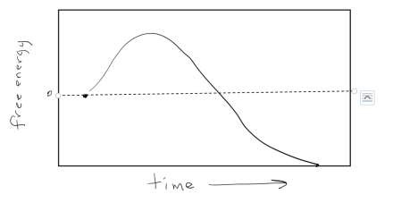

1. How does a *catalyst* affect the activation energy required for a chemical reaction?

1. This is a simplified sketch of a molecule of ATP. Circle the ribose *sugar*, use an arrow to point to the adenine *base*, and use a bracket to label the *phosphates*. Label each part.

1. How is the structure of ATP (shown in 15, above) different from the structure of an adenine nucleotide in

DNA?

1. Using a similar diagram to the one in 14, above, draw a simple sketch of ADP.

1. Explain why ATP is not good for long-term energy storage.

1. The chief molecule used for energy transactions in all cells is ____________________.

1. The acronym “ATP” stands for _________________________ _________________________.

The acronym “ADP” stands for _________________________ _________________________.

The acronym “AMP” stands for _________________________ _________________________.

1. The symbols shown below stand for an inorganic ____________________. What does “inorganic” mean? *Hint: You may want to do a search of the words “organic” and “inorganic”.*

1. Look at this drawing of the ATP cycle. Then, use your voice to tell the story of how ATP is generated, used, and recycled in cells. (Be sure to include how ATP, inorganic phosphate and ADP are involved in the story. Also include the concepts endergonic, hydrolysis, and exergonic.) *Use your own words. It’s okay if you’re just talking to your dog.*

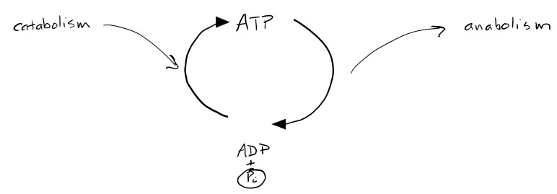

Consider the drawing above and note how the far left side refers to cells’ many catabolic processes (which release energy), and the far right side refers to the cell’s many anabolic processes (which require energy input). Now, look *only* at the actual ATP cycle shown in the circular center portion of the diagram. Which part of the ***ATP cycle itself***is catabolic (exergonic) and which part is anabolic (endergonic)? Label these parts of the circular ATP cycle in the simple sketch below.

1. Complete this table.

|  |  |  |
| --- | --- | --- |
| Cellular Process | Catabolic or Anabolic? | Exergonic or Endergonic? |
|  |  |  |
|  |  |  |
|  |  |  |
|  |  |  |

1. Draw simple sketches of an enzyme and its substrate as they appear before a chemical reaction. Label the active site of the enzyme. Now draw a sketch of the enzyme-substrate complex. And lastly… draw the enzyme only as it appears *after* the reaction.

|  |  |  |  |
| --- | --- | --- | --- |
| enzyme | substrate | enzyme-substrate complex | enzyme after reaction |

1. Cells have many different types of enzyme molecules. Explain why a particular enzyme only interacts with a specific type of substrate. *Hint: It has to do with structure (“form”).*

1. Although some *enzymes*, known as “ribozymes”, are made of RNA, most are made of _______________.

1. When the appropriate enzyme is present, a chemical reaction is __________ (more/less) likely to occur.

1. Do you think this is True or False? Each cell has only one molecule of each type of enzyme. __________

1. Do you think this is True or False? Once an enzyme helps get a certain type of reaction started, it is unable to do so again. __________

1. By reducing the activation energy required, an enzyme _______________ (increases/decreases) the chances that a particular chemical reaction will occur.

1. The rate of a particular chemical reaction (how often it occurs in a given time period) is _______________ (increased/decreased) when the appropriate enzyme is involved.

1. One of the sketches below represents an enzyme that can no longer function because it has denatured. Circle the denatured enzyme.

1. How does an enzyme affect the activation energy for a reaction?

1. Molecules called inhibitors can keep an enzyme from doing its job. Label each of the diagrams below to indicate *competitive* or *noncompetitive*/*allosteric* inhibition.

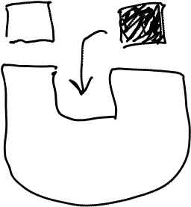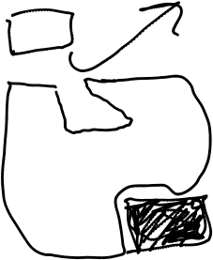

____________________ _____________________

1. Define “active site” and “substrate”.

1. Describe **two** things that can happen at the allosteric site of an enzyme.

1. Complete this table.

|  |  |  |
| --- | --- | --- |
|  | Assists or Inhibits Enzyme? | Description/Example |
|  |  |  |
|  |  |  |

1. Complete this table.

|  |  |
| --- | --- |
|  | Description |
| metabolism |  |
| anabolism |  |
| catabolism |  |

1. Draw a simple sketch of a biochemical pathway having 3 enzymatic steps. Label the *initial substrate* and the *end product*. Show how the end product can act as an inhibitor for the first step in the pathway. This type of end product action is known as ___________________ inhibition.

**Chapter 7 – CELLULAR RESPIRATION**

1. Energy from the chemical bonds in glucose is extracted and converted into a form that living things can use in a series of metabolic pathways collectively called __________________________________________.
2. Define “redox”.

1. In reduction, a molecule ____________ an electron. In *oxidation*, a molecule loses an ____________. In *dehydrogenation*, a molecule loses a ___________, which consists of an electron **and** a ___________.

*Hint: Think of an atom of the lightest element, which consists of only two particles.*

1. Draw a sketch showing a molecule being oxidized, and a sketch showing a molecule being reduced. Use a large circle to represent “a molecule”, and a small molecule with a “-“ (minus) sign to represent an electron.

|  |  |
| --- | --- |
| oxidized | reduced |
|  |  |

1. “Redox” is a combination of two terms. They are ____________________ and ___________________.
2. In cellular respiration, ____________________ is incrementally released from glucose as electrons are eventually transferred to a final electron acceptor.
3. The electron carrier NAD has two forms, NAD+ and NADH. Which one is the reduced form? ____________ Which form has more potential energy? ____________
4. Define “phosphorylation” and “dephosphorylation”.
5. ADP is phosphorylated to make ATP during glycolysis, the Citric Acid Cycle, and by way of the electron transport chain with chemiosmosis. Which two of these processes make ATP by way of *substrate-level phosphorylation*?

Which one of these processes makes ATP by way of *oxidative phosphorylation*?

*Note: The Citric Acid Cycle is also known as the “Krebs cycle” or “tricarboxylic acid cycle”.*

1. Glycolysis is an aerobic / anaerobic process. (Circle one)
2. Glycolysis begins with a molecule of ______________ and ends with two molecules of ______________.

How many net molecules of ATP are made during the breakdown of one glucose during *glycolysis*? _____

1. Draw a simple diagram of an animal cell, including the plasma membrane and the nucleus. Also include an unrealistically large mitochondrion, showing its internal details. Use arrows and labels to identify the cellular locations of glycolysis, the Citric Acid Cycle, and the electron transport chain.

1. Consult Figures 7.6 and 7.7to draw and label a simple overview of glycolysis. You do not need to diagram/name every intermediate molecule Note where 2 ATP are used, and where 4 ATP are made. Note where 2 NAD+ are used to make NADH. Notice glucose and pyruvate. Note “G3P”.

1. Consider the relatively short process of “pyruvate oxidation”. It turns pyruvate into _______________. It generates _______________ as a waste product.

Fill in the label blanks for this diagram.

1. At the start of the Krebs cycle, acetyl-CoA combines with ___________________________________.
2. Create a simplified version of Figure 7.9 showing the Citric Acid Cycle. Begin by drawing a large circle. Show the locations of acetyl-CoA and oxaloacetate. Also show the events depicted on the outside of the circle involving GTP (equivalent to ATP), CO2, and the two types of electron carriers. You do not need to draw the other 4- and 5-carbon molecules.

1. For each glucose molecule broken down in glycolysis, how many times does the Citric Acid Cycle happen?
2. Identify how many of each molecule are produced by the Citric Acid Cycle:

|  |  |  |  |  |
| --- | --- | --- | --- | --- |
|  | NADH | FADH2 | ATP | CO2 waste |
| One complete turn of the cycle |  |  |  |  |
| Two complete turns (representing  breakdown of one glucose) |  |  |  |  |

1. The electron transport chain requires a constant supply of electrons. Which molecules deliver electrons to the electron transport chain?

1. When NADH releases an electron, it becomes ____________________.
2. In our cells, the final electron acceptor at the end of the electron transport chain is ___________________.
3. As *electrons* move through the electron transport chain, energy is released. This energy is ***used*** to move _________________________ from the _______________________ to the _______________________.

This process maintains an “electrochemical gradient”.

1. Chemiosmosis is not the same as osmosis. Define chemiosmosis.

1. When protons are crowded in the in the intermembrane space of the mitochondrion, they move back into the matrix by passing through the enzyme known as ___________________________________. This enzyme uses the mechanical energy from the flow of particles to rotate, and make a lot of ____________________.
2. Why do you suppose the process described in 26, above, is called “oxidative” phosphorylation.

1. If a cell performs cellular respiration, all the way from glycolysis to the electron transport chain/chemiosmosis, it theoretically can generate more than 30 ATP from the breakdown of one glucose. How many ATP does glycolysis alone generate? _____
2. In what way does the enzyme *phosphofructokinase* help regulate the catabolism of glucose?

1. True or False?: When oxygen is absent, cells cannot breakdown glucose. (circle one) True False
2. For glycolysis to happen continuously, there must be a constant supply of NAD+. But glycolysis uses up NAD+, converting it to NADH. How can the NADH be *recycled* and converted back into NAD+? Name two versions of the anaerobic (oxygen-free) process that can make this can happen. Then **explain** what actually happens to the NADH as it is converted back into NAD+. Do not use anaerobic respiration as an answer.

1. *______________________________ 2. ______________________________*

1. Which of the above processes occurs in animal muscle cells that have run out of oxygen?

1. In some cells, fermentation is essential to the continued use of glycolysis. Why?

1. The purpose of fermentation is to regenerate _______________ that is depleted by glycolysis.
2. Why is fermentation referred to as an “anaerobic” process?

1. Name two waste products generated by two different types of fermentation. *Hint: Both of them have been used by humans for food/beverage manufacturing.*

___________________________________ ___________________________________

1. What type of fermentation actually occurs for short periods of time in parts of the human body?

1. True or False: Amino acids from proteins, as well as fats, can be broken down and used partway through the cellular respiration pathway. (Circle one)

1. Write a summary chemical equation for catabolism of glucose in cellular respiration, using chemical formulas. Write the names of the compounds underneath the formulas. Label the reactants and the products. Include glucose, oxygen, water, carbon dioxide, and ATP.

1. What is the role of phosphofructokinase in regulating metabolism?

1. How does the inhibition process above help cells save energy?

**Chapter 8 – PHOTOSYNTHESIS**

1

.

Complete this table.

*Hint: Refer to Chapter 4*

*, if needed*

*.*

Can make its

own food?

(

)

yes/no

Example

1. The energy used by life originally arrives at Earth in the form of ____________________.
2. Write a chemical equation for photosynthesis, using chemical formulas. Write the names of the compounds in words underneath the formulas. Label the reactants and the products.

1. What happens in the stages of photosynthesis? *Hint: Figure 8.7 shows some of the molecules involved.*

Stage 1: Capturing light energy and using the energy to make __________ and __________. (molecules)

Stage 2: Uses the molecules from stage 1, plus ____________from the atmosphere, to make __________.

1. Draw a simple diagram of a plant cell, including the plasma membrane, cell wall, and the nucleus. Also include an unrealistically large chloroplast, showing its internal details. To remind you that plants also have mitochondria, include one of them as well. Use arrows and labels to identify the cellular locations of the light reactions, the electron transport chain, and the Calvin cycle.

1. Define carbon fixation.

1. Why are some parts of photosynthesis referred to as “light-independent”?

1. Where in the chloroplast is chlorophyll located?

1. Draw a chloroplast showing its internal structural details. Identify the stroma and the thylakoid space. Use an arrow to indicate the direction protons are pumped by the electron transport chain.

1. Define these words:

Pigment

Photon

Photosystem

Wavelength

1. Use terms from 10, above, to complete this sentence: In a __________________ (which is located in the thylakoid membrane), an electron in a ____________________ molecule becomes excited when it is struck by a ____________________.

1. Once the electron mentioned in item 11, above, becomes excited, it can enter the _______________ _______________ _______________.
2. Different colors of light have different ____________________, which are measured in nanometers.
3. What colors/wavelengths of light are **not** well utilized by plants? ______________________________
4. Define *photoact (or “photoelectric effect”).*

1. How do accessory pigments other than chlorophyll contribute to photosynthesis?

1. Redraw and assemble the components shown below to represent a simplified version of a complete chlorophyll molecule.

1

8

.

Draw the

absorption spectrum

for chlorophyll a.

1. Draw a diagram of a photosystem, showing the reaction center chlorophyll and a few other chlorophylls of the antenna complex. Represent the photons hitting the system. Show an electron leaving the system and joining with the electron acceptor. Show the electron donor providing an electron to replace the one that left the system.

1. Consider the diagram in item 19, above. What photosystem molecule serves as the electron donor?

_____________ Label it above. In what membrane is the photosystem located? _____________ Add this membrane to your drawing.

1. Briefly, in your own words, explain how a photosystem converts light energy into chemical energy.

1. Briefly describe the four stages of reactions that occur at the thylakoids.

|  |
| --- |
| Light energy captured |
| Electron transferred |
| Electron transport chain |
| Chemiosmosis |

1. Create your own definition for the term *photophosphorylation*. FIG 7.12 MAY PROVIDE INSPIRATION

1. Label the locations of these parts of the light reactions on the Z diagram framework provided below.

*Hint: Try to figure this out on your own. If needed, do a web search for the “Z scheme” of photosynthesis.*

Photosystem I, Photosystem II, photons, water, oxygen, NADPH, electron transport chain. Use arrows as needed to show the relationships among these components. **Then**, draw one long arrow to represent the path of an electron in noncyclic photophosphorylation.

Photosystem I

Photosystem

II

1. Draw a simple diagram of a chloroplast. Identify the location of ATP synthase. Identify the compartment where proton concentration is high.

1. What is the role of water in photosynthesis*? Hint: Figure 8.16*

1. Name the cycle during which carbon fixation occurs. ______________________________ Where in the cell does this process occur? ___________________________________________________________
2. The anabolic production of food molecules occurs during the Calvin cycle. The process requires ATP for energy and electrons for reduction. What is the source of this ATP and the molecules carrying the electrons?

1. Draw a circle representing the Calvin cycle. Label the locations of CO2, rubisco, and G3P. Show how two G3P can combine to make the well-known food, glucose. Along the outside of the circle, used labeled curved arrows to show where ATP and NADH are used.

1. On the above diagram of the Calvin cycle, identify the enzyme responsible for carbon fixation.
2. In general, molecules containing carbon are referred to as “organic”. An exception is the so-called “inorganic” carbon source used by plants, _______.

What is the name, in two words, of this compound? ____________________ ____________________

1. How many times must the Calvin cycle turn to account for the production of one glucose molecule? ______ *Hint: 1 glucose = 2 G3Ps*
2. Plants generate food during photosynthesis. In what organelle can they use this food for large-scale ATP production? _________________________ If the plant does not need the ATP right away, it can be stored in the form of _______________ molecules. *Hint: Think of a polysaccharide.*
3. Explain why water is needed for photosynthesis. First, use your own words. Then include a labelled diagram showing the location in the photosynthesis metabolic pathway.

1. Explain why oxygen is released in photosynthesis. First, use your own words. Then include a labelled diagram showing the location in the photosynthesis metabolic pathway.

1. Explain why carbon dioxide is used in photosynthesis. First, use your own words. Then include a labelled diagram of the location of CO2 in the photosynthesis metabolic pathway.

1. Fill in the label blanks on this diagram to show what is used/released during the processes of photosynthesis and cellular respiration.